SALIM KOMESHA
671338
END SEM-DSA3050
POWER QUERY – DATA CLEANING & TRANSFORMATION
1.Raw data
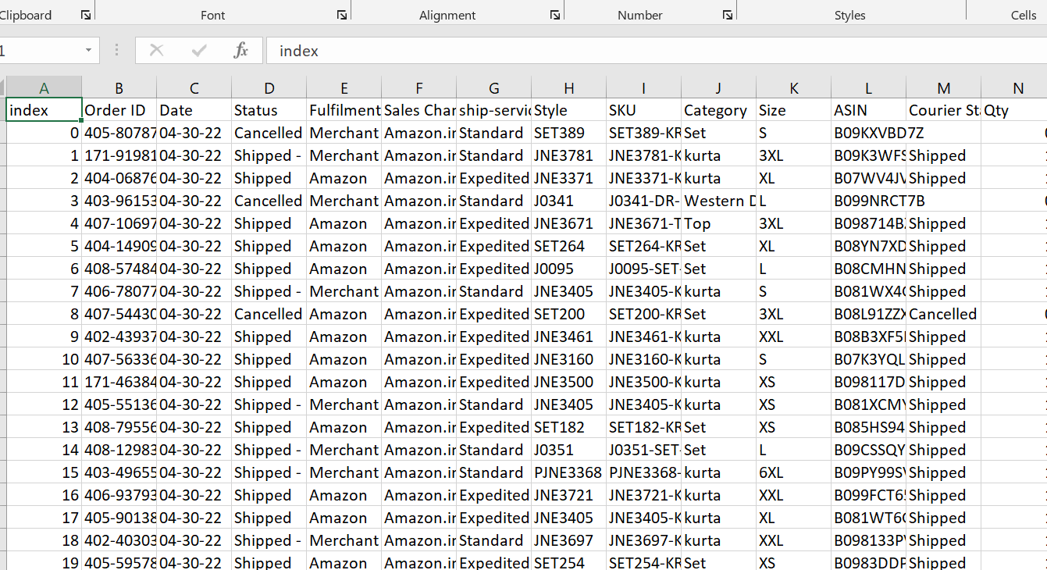

2.Power query
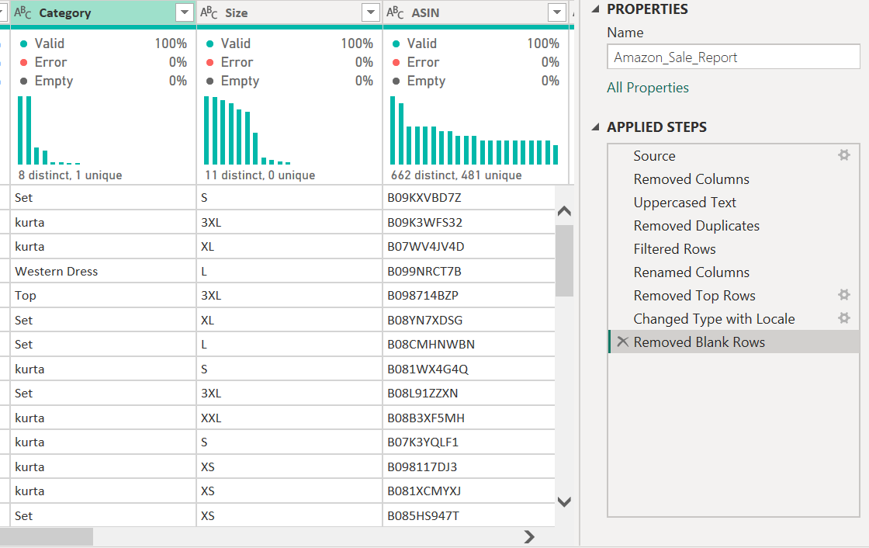

3.Model
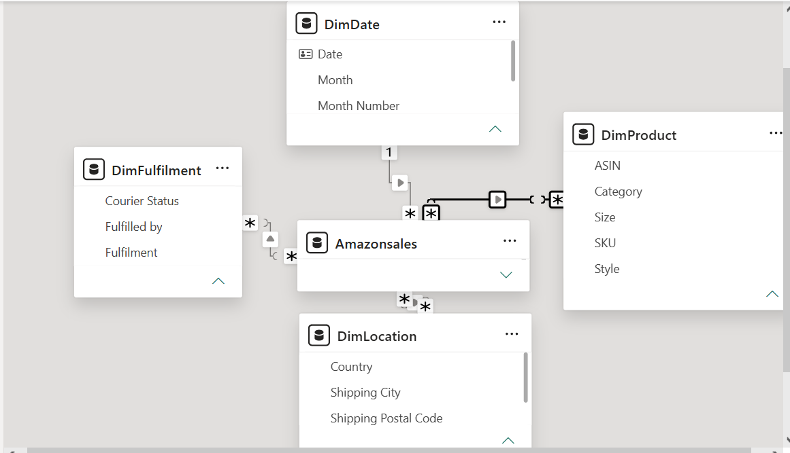

4.Dashboard overview
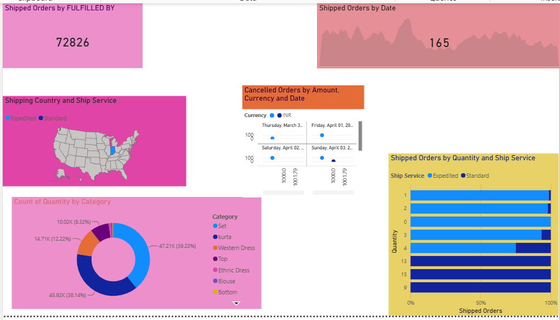
5.Dashboard analysis
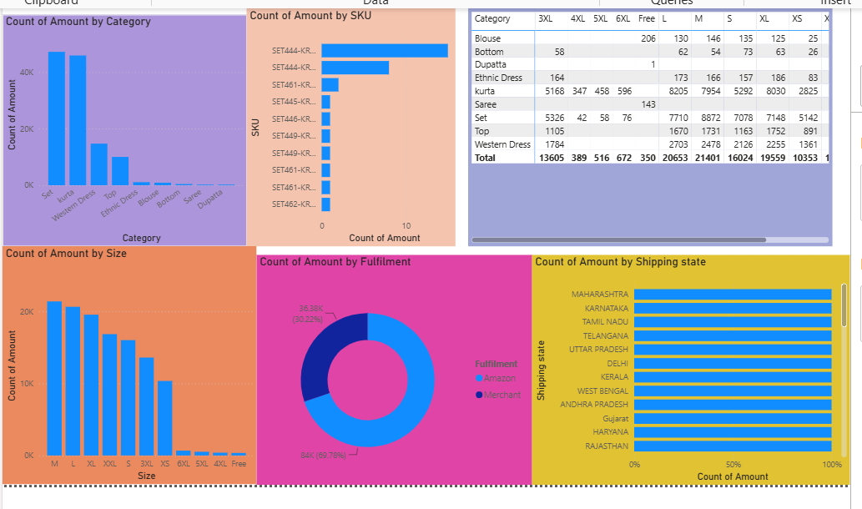
6.Dashboard insights
